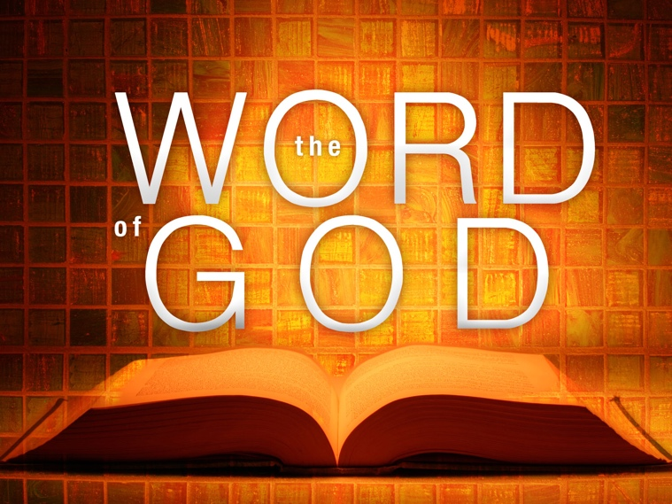The Word of God is essential for the Christian. Without it we will not fulfill God’s purposes for us. God’s purposes involve change of behavior, supporting our local church, and reaching unbelievers and helping them have a relationship with God. Reaching these goals require being changed from the inside out. We do not have the power to change on our own. We need help from God. His Word is what He uses to help us change. In this study will cover several principles about the Word of God.

1. **The Bible is Gods Word**

The Bible is The Word of God which consist of 66 Books written by at least 40 different authors of different backgrounds. Though men were used as a part of the recording process the Bible is completely breathed by God. It is the final authority in the life of the Christian.

The Word from God came through the Prophets. Deut. 18:15 – 22

* Prophets spoke the Word as they were moved by the Holy Ghost. 2 Pet. 1:21
* Prophets wrote down what God said. Exod. 24:1 – 4
* The Scripture is called the Word of God. Daniel 9:2
* The Scripture is inspired by God. 2 Tim. 3:16 – 17
* Paul’s words are equated with the Scriptures. 2 Pet. 3:15 – 16
* God’s Word is identified as a book and the Law. 2 Chron. 34:14 and 21

We conclude that God spoke to prophets, His words were eventually written on scrolls, and later formed as books. These writings or books were referred to the listeners and readers during that time by the Old and New Testament prophets and apostles as being authoritative. They are equally authoritative for the modern Christian. The Bible is breathed by God and is to be the final authority in all matters of faith and practice for the Christian.

1. **Why read the Bible?** Reading involves studying, and meditating also**.** We read, study, and meditate on the Word of God to be equipped. 2 Tim. 3:16 – 17. Equipping is to furnish someone with training and development to help the person become mature in Christ. Reading the Bible will help us grow to maturity. 1 Pet. 1:22 – 2:3; Heb. 5:11 – 6:3As you grow to maturity you will be able…

* To discern truth from error. 2 Tim. 2:15; Acts 17:11
* To stand against Satanic influence. Matt. 4:4, Eph. 6:17
* To overcome sinful practices. Psalms 119:11
* To strengthen your Soul. Psalms 119:28
* To be purified of worldliness. 1 John 2:15 – 17; Eph 5:17 - 29
* To receive comfort during suffering. Psalms 119:50
* To be kept from deceitful ways. Psalms 119:29

1. **Why Hear the Bible?** We hear the Word through through preaching and teaching. Preaching and teaching explains to clarify what the Bible teaches. Hearing helps believers:

* To come to faith in Christ. Acts 2:37 – 38; Rom. 10:17
* To be established in the truth. Acts 18:24 – 28
* To learn healthy teaching. Titus 2:1 – 3
* To be protected from erroneous teaching. 1 Tim. 4:6,13
* To be used by God to teach and encourage others. 2 Tim. 2:1 – 2
* To produce fruit. Matt. 13:18 – 23

1. **Why should we be a doer of the Bible? This is the ultimate stage of Bible reading. Reading the Bible is important. Yet we must take the next step by applying what it says in our lives. So here are some reasons and ways we can apply the Bible in our lives:**

* To attract unbelievers to Christ. Matthew 6:13 – 16
* To set an example to other Believers in Christ to follow. 1 Tim. 4:12;

1 Thessalonians 3:6 – 10

* To overcome self deception. James 1:22 – 27
* To be successful in all we do. Joshua 1:6 – 8
* The Bible gives us direction. Psalms 119:105
* To be blessed in all that we do. James 1:22 – 25